DATA ANALYTICS PROJECT
E-Commerce Analytics: End-to-End Project
From SQL data cleaning to Python analysis, hypothesis testing and an interactive dashboard
Item | Details
Student | Muhammad Usman
Degree / Program | BS Data Analytics
University | Arid Agriculture University, Rawalpindi
Date | 7 October 2026

1. Executive Summary
This project analyses the performance of an e-commerce business using a set of Python-generated charts and an interactive performance dashboard. The material covers monthly revenue and profit from January 2024 to July 2026, performance by product category, region, product and payment method, the relationship between discounts, prices, quantities and profit, and the reasons customers return products.
Data analysed. The dashboard reports total revenue of 153.31M and total profit of 52.52M, which gives an overall profit margin of 34.26%. The average revenue per transaction is 13.98K and the displayed return rate is 5.14. The charts imply roughly 10,900 to 11,000 transaction-level records, although the exact record count is not stated in the material provided.
Approach. The data is stored in a PostgreSQL database (Ecommerce_Analytics) made up of five related tables, which were checked for duplicate and null values with SQL. The analysis is descriptive and exploratory. It uses histograms and a box plot for distributions, line charts for monthly trends, bar charts for category, region and payment comparisons, scatter plots and a correlation matrix for relationships, and a return-reason chart, all brought together in a filterable dashboard. A Welch t-test in Python then tests formally whether discounted orders differ from non-discounted orders in average order value.
Most important findings:
- Profit moves closely with revenue. The profit margin stays stable at about 33% to 35.5% from month to month and at about 34% to 35% across all four regions.
- Home and Electronics are the strongest categories and together generate about 53% of revenue. Books earn the least revenue but appear to have the highest margin (about 38%).
- The East region is the clear weak point, contributing only 10.71% of revenue, while North, South and West each contribute between 28% and 31%.
- Higher discounts are associated with lower profit (correlation −0.24). Loss-making transactions appear only at the 20% and 25% discount levels.
- UPI is the most used payment method, followed by credit card. February is the weakest month in every year observed.
- Returns are spread across five reasons. About 58% of the returns relate to damaged items, wrong products or late delivery, which are operational issues.
Key conclusion. The business is consistently profitable, so the main opportunities lie in growing volume in the East region, managing deep discounts, and reducing fulfilment-related returns, rather than in repairing overall margin.

2. Introduction

2.1 Background
E-commerce businesses record every transaction, including what was sold, where, at what price and discount, how it was paid for, and whether it was later returned. When these records are analysed well, they show which products and regions create value and where money or customer satisfaction is being lost.

2.2 Problem and context
The provided material describes a retail business selling products in five categories (Beauty, Books, Electronics, Fashion and Home) across four regions (East, North, South and West). The business name and the source of the data are not stated. The central question is how the business has performed, and which factors help or hurt its sales, profit and customer experience.

2.3 Purpose and usefulness
The purpose of this project is to turn raw transaction data into clear, evidence-based insights. Such insights help decision makers choose which categories to promote, which regions need attention, how far discounts should go, which payment options to support, and how to reduce returns. The final dashboard also allows non-technical users to explore the same results interactively.

2.4 Tools and workflow
The project follows a workflow from raw files to decisions, using three main tools:
- PostgreSQL 18 and pgAdmin. The five source tables were loaded into a database named Ecommerce_Analytics, where duplicate checks, null checks and queries were run in SQL.
- Python (Jupyter Notebook and VS Code). Python produced the exploratory charts and the Welch t-test on discounts (Hypothesis_Testing.py).
- Interactive dashboard. The dashboard brings the main KPIs, filters and charts onto one page for non-technical users.

3. Objectives
The project has the following objectives:
- Measure overall business performance using revenue, profit, profit margin, average revenue and return rate.
- Examine the distribution of sales amount and profit per transaction, including outliers.
- Identify monthly revenue and profit patterns between January 2024 and July 2026.
- Compare performance across product categories, regions and individual products.
- Analyse payment method usage and its contribution to revenue.
- Investigate how discount, unit price and quantity relate to sales amount and profit.
- Understand why products are returned.
- Store, clean and validate the data in a PostgreSQL relational database using SQL duplicate and null checks.
- Test with a Welch t-test whether discounted orders have a different average order value from non-discounted orders.
- Summarise the results in an interactive dashboard and derive practical, data-based recommendations.

4. Dataset Description

4.1 Source and size
The data is stored in a PostgreSQL 18 database named Ecommerce_Analytics, built in pgAdmin from five CSV files. Table 1A lists the tables. The original source of the CSV files is not stated in this report.
Table 1A: Tables in the Ecommerce_Analytics database
Table | Role in the analysis
customers | Customer details (for example age and gender)
products | Product and category details
orders | Order-level records (for example date, status and payment)
orderdetails | Items within each order (for example quantity, price and discount)
returns | Returned orders and the reason for each return

The following facts can be determined from the charts and dashboard produced from this data:
- Time period: monthly data from January 2024 to July 2026 (31 months), as shown on the axis of Figures 3 and 4.
- Number of records: the exact number is not provided. The average revenue of 13.98K and total revenue of 153.31M imply about 10,970 transaction-level records. The payment method chart (Figure 9) supports this, with bars summing to roughly 10,900 orders.
- Dashboard Total Orders: the dashboard card shows 4.386K. This differs from the roughly 10,970 records implied above, and the material does not explain how Total Orders is defined. Because the database keeps orders and order items in separate tables, a likely explanation is that Total Orders counts rows in the orders table while the ≈10,970 records are individual order lines. A row count on each table would confirm this.
- Number of variables: not stated. The variables identifiable from the charts are listed in Table 1.
Table 1: Variables identifiable from the charts and dashboard
Variable | Type (as evident from charts) | Values or range observed
age | Numeric | Used in the correlation matrix only (Figure 12)
quantity | Numeric (discrete) | 1 to 4 items per transaction (Figure 11)
unitprice | Numeric (continuous) | Range not shown directly; implied up to about 14K
discountpct | Numeric (discrete) | 0%, 5%, 10%, 15%, 20%, 25% (Figure 10)
salesamount | Numeric (continuous) | About 0.3K to 57K per transaction (Figure 1)
profit | Numeric (continuous) | About −2K to 31K per transaction (Figure 2)
category | Categorical | Beauty, Books, Electronics, Fashion, Home
region | Categorical | East, North, South, West
product | Categorical | At least 10 products (Figure 14)
payment method | Categorical | COD, Credit Card, Debit Card, Net Banking, UPI
return reason | Categorical | Damaged, Wrong Product, Size Issue, Late Delivery, Not Satisfied
gender, orderstatus | Categorical (dashboard filters) | Filter values are not visible in the material
date (year-month) | Date / time | 2024-01 to 2026-07

4.2 Relevant characteristics
- Both sales amount and profit are right-skewed: most transactions are small to medium and a few are very large.
- Discounts are applied in fixed steps of 5 percentage points, from 0% to 25%.
- Quantity per transaction is limited to 1 to 4 items.
- A small number of transactions have zero or negative profit.

5. Data Preparation and Cleaning
Data preparation had two parts. The CSV files were loaded into PostgreSQL, where each table was checked with SQL for duplicate records and null values (Section 5.1). The remaining steps, which can be seen in the charts and dashboard, are summarised in Table 2.
Table 2: Data preparation steps and the evidence for them
Step | Evidence in the provided material | Status
Consistent column naming | Variables appear in a uniform lowercase style (for example salesamount, unitprice, discountpct) in the correlation matrix. | Evident
Date feature | Figures 3 and 4 plot revenue and profit against a year-month field (axis label “Year With Month”), and the dashboard has a Month filter. | Evident
Derived metrics | Profit % of 34.26% on the dashboard equals 52.52M divided by 153.31M. Average revenue per transaction is also reported. | Evident
Outlier inspection | A box plot of sales amount was produced (Figure 13). The high values are still present in Figures 1 and 11, so no removal is shown. | Inspected, not removed
Negative profit values | Negative profit remains visible in Figures 2 and 10. | Retained
Missing values and duplicates | SQL duplicate checks and null checks were run on each of the five tables (Section 5.1). | Performed; results to add
Data type conversion | No evidence is shown in the material. | Cannot be determined

5.1 SQL cleaning workflow
Cleaning was done in SQL before any analysis:
- The five CSV files were loaded into the Ecommerce_Analytics database in PostgreSQL 18 using pgAdmin.
- Each table was checked for duplicate records.
- Each table was checked for null values.
[Add the results: how many duplicate rows and null values were found in each table, and whether they were removed, filled or kept. A short table with one row per table works well here.]

6. Exploratory Data Analysis
This section examines each chart in turn. Values quoted from the dashboard are exact as displayed. Values marked with “≈” were read from the chart axes and are approximate. Each figure is followed by an Observation (what the chart shows) and an Interpretation (what it means).

6.1 Distribution of sales and profit
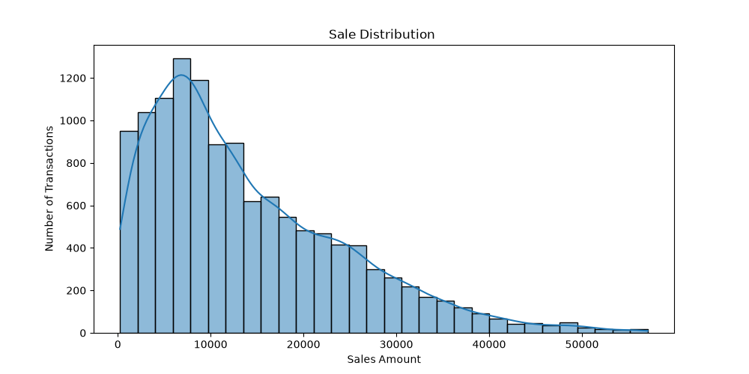
Figure 1: Sale Distribution
Observation. The histogram shows the number of transactions at each sales amount. The tallest bar is at roughly 6,000 to 8,000, with about 1,290 transactions. Counts fall steadily beyond about 13,000, and the tail reaches about 57,000. About 950 transactions fall in the lowest bar, near zero.
Interpretation. The distribution is right-skewed. Most transactions are small to medium in value, and a small number of high-value orders stretch the tail. This explains why the dashboard average revenue (13.98K) is higher than the most common value.
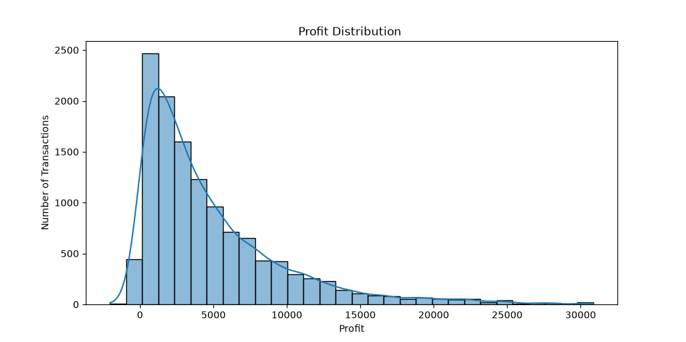
Figure 2: Profit Distribution
Observation. Profit per transaction is also strongly right-skewed. The two tallest bars lie between roughly 0 and 2,500 and contain about 2,470 and 2,040 transactions. The tail extends to about 31,000. A small bar sits near zero and another near −2,000.
Interpretation. Most transactions earn a modest profit, and large profits are rare. Some transactions earn little or lose money. Because the bar near zero covers values on both sides of zero, the exact number of loss-making transactions cannot be read from this chart.
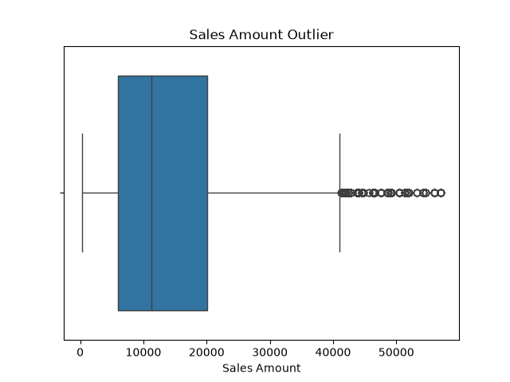
Figure 3: Sales Amount Outlier
Observation. The box plot shows a median of about 11,000 and a central half of the data (interquartile range) between about 5,700 and 20,000. The upper whisker ends at about 41,000, and many points beyond it, up to about 57,000, are flagged as outliers. No outliers appear at the low end.
Interpretation. The median (about 11,000) is below the average of 13.98K, which confirms the positive skew. The highest values match the largest transactions in Figure 11, where four-item orders reach about 57,000, so these outliers look like genuine high-value orders rather than obvious errors. This cannot be confirmed without the raw data.

6.2 Monthly revenue and profit trends
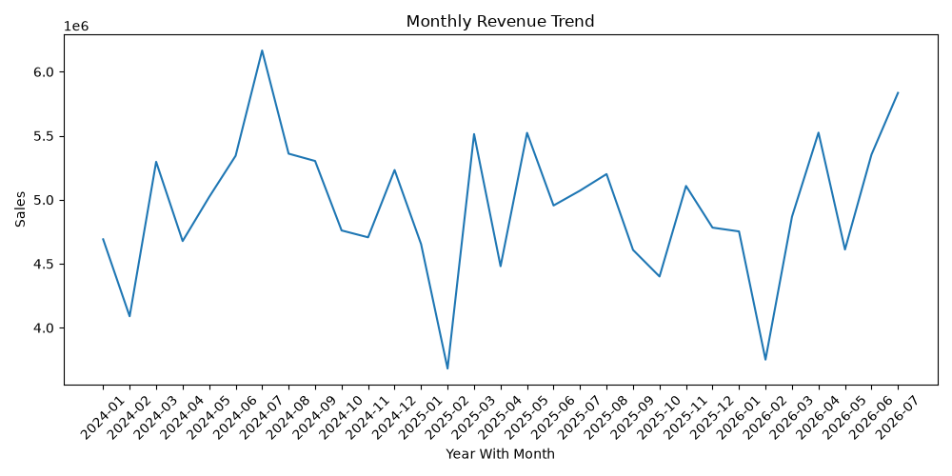
Figure 4: Monthly Revenue Trend
Observation. Monthly revenue ranges from about 3.74M to 6.14M. The peak is July 2024 (≈6.14M) and the lowest point is February 2025 (≈3.74M). February is low in every year: ≈4.13M (2024), ≈3.74M (2025) and ≈3.79M (2026). The most recent month, July 2026 (≈5.83M), is the second highest in the series. Revenue often rebounds sharply after a low month, for example from ≈3.74M in February 2025 to ≈5.48M in March 2025.
Interpretation. Revenue is volatile but shows no clear long-term rise or fall: it keeps returning to the same band of roughly 4.5M to 5.5M. The repeated February dip suggests a seasonal pattern, although three observations of one month are too few to be certain. The monthly average over the 31 months is about 4.95M (153.31M ÷ 31).
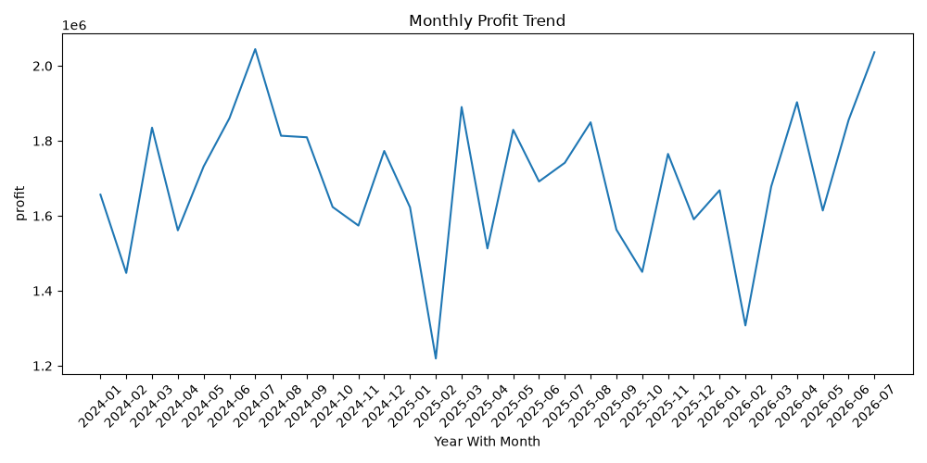
Figure 5: Monthly Profit Trend
Observation. Monthly profit follows almost exactly the same shape as revenue. It peaks at about 2.0M in both July 2024 (≈2.04M) and July 2026 (≈2.03M), and reaches its lowest point of ≈1.24M in February 2025.
Interpretation. Dividing the monthly profit by revenue gives a margin of about 33% to 35.5% in every month. Profit therefore rises and falls because of sales volume, not because of changing margins. Growing revenue is the main way to grow profit.

6.3 Category performance
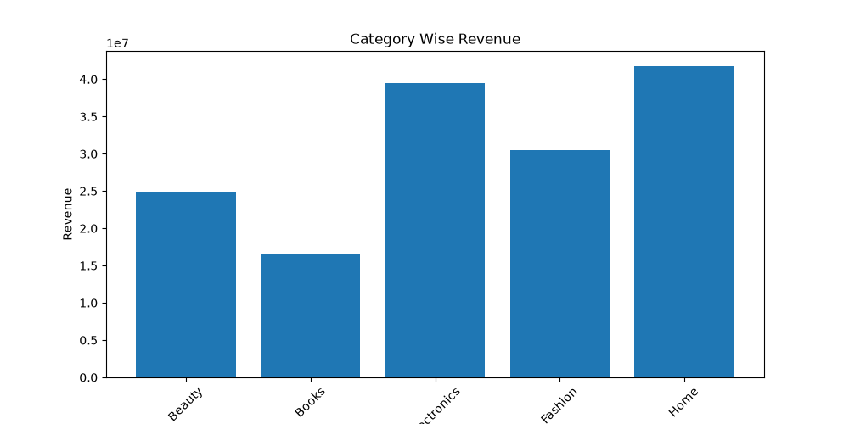
Figure 6: Category Wise Revenue
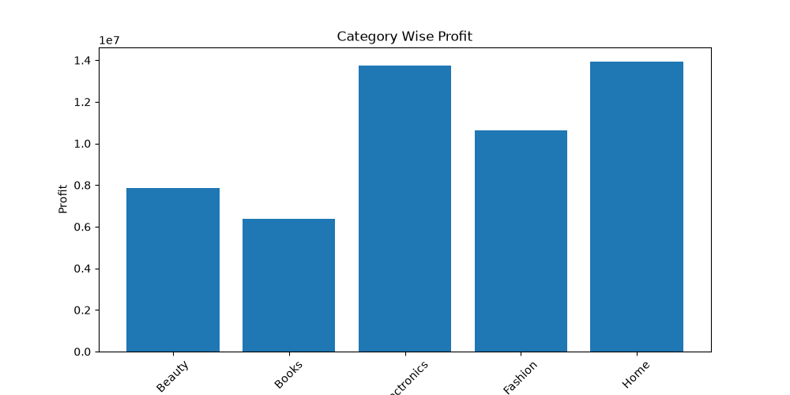
Figure 7: Category Wise Profit
Table 3: Revenue and profit by category (approximate values read from Figures 5 and 6)
Category | Revenue (M) | Revenue share | Profit (M) | Approx. margin
Home | ≈41.7 | ≈27% | ≈13.9 | ≈33%
Electronics | ≈39.4 | ≈26% | ≈13.7 | ≈35%
Fashion | ≈30.5 | ≈20% | ≈10.6 | ≈35%
Beauty | ≈24.9 | ≈16% | ≈7.8 | ≈31%
Books | ≈16.6 | ≈11% | ≈6.4 | ≈38%

Observation. Home (≈41.7M) and Electronics (≈39.4M) are the two largest categories by revenue and profit. Fashion is third, followed by Beauty. Books are clearly the smallest category in both revenue (≈16.6M) and profit (≈6.4M).
Interpretation. Home and Electronics together provide about 53% of total revenue. Margins differ moderately between categories: Books have the highest estimated margin (about 38%) despite their small size, while Beauty has the lowest (about 31%). The category figures are read from chart axes, so margins should be treated as estimates of about ±1 percentage point.

6.4 Regional performance
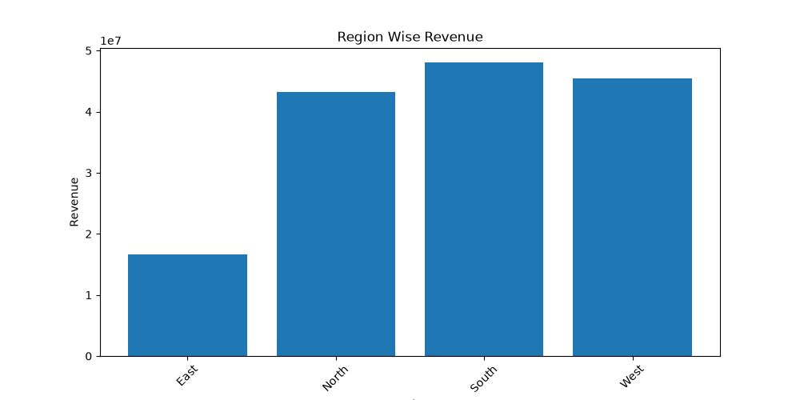
Figure 8: Region Wise Revenue
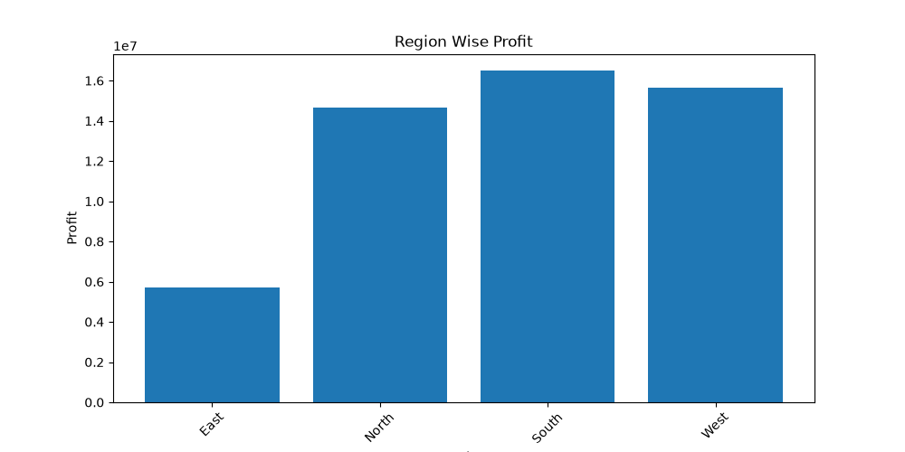
Figure 9: Region Wise Profit
Table 4: Revenue and profit by region
Region | Revenue share (dashboard) | Revenue (M) | Profit (M) | Approx. margin
South | 31.19% | ≈47.8 | ≈16.5 | ≈35%
West | 29.93% | ≈45.9 | ≈15.6 | ≈34%
North | 28.16% | ≈43.2 | ≈14.7 | ≈34%
East | 10.71% | ≈16.4 | ≈5.7 | ≈35%

Revenue shares are taken from the dashboard pie chart. Revenue in millions is those shares applied to the 153.31M total, and profit is read from Figure 8.
Observation. South leads in both revenue and profit, followed by West and North, which are close to each other. East is far behind, with about one third of the revenue of any other region.
Interpretation. The East region's weakness is a volume problem, not a margin problem: its estimated margin (about 35%) is in line with the other regions. This makes East the clearest growth opportunity. The material does not contain customer, marketing or logistics data, so the reasons for the low volume cannot be determined.

6.5 Top products
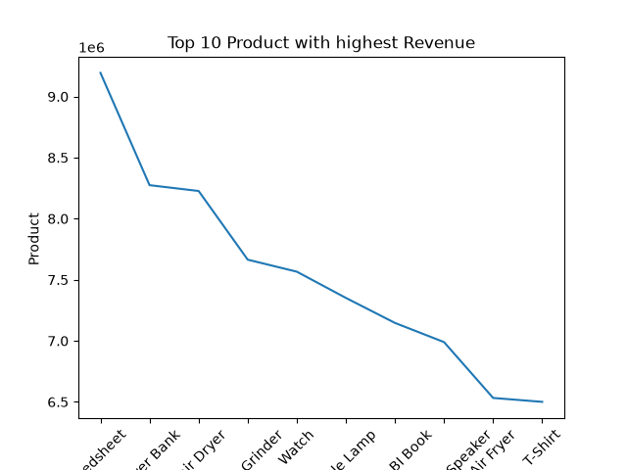
Figure 10: Top 10 Products with Highest Revenue
Observation. The chart ranks the ten highest-revenue products. Some axis labels are cut off, so the names below are reconstructed from the visible text and the dashboard: Bedsheet (≈9.2M), Power Bank (≈8.3M), Hair Dryer (≈8.2M), Mixer Grinder (≈7.7M), Watch (≈7.6M), Table Lamp (≈7.4M), Power BI Book (≈7.2M), Bluetooth Speaker (≈7.0M), Air Fryer (≈6.5M) and T-Shirt (≈6.5M). Revenue declines steadily down the ranking, with the largest gap between first and second place.
Interpretation. Bedsheet is the top product on both this chart and the dashboard. Together the ten products account for about 75M, roughly half of total revenue, but the total number of products is not provided, so the degree of concentration cannot be fully judged. Home-related items (Bedsheet, Hair Dryer, Mixer Grinder, Table Lamp, Air Fryer) feature strongly, which is consistent with Home being the top category. The product-to-category mapping is not shown in the material.
Note: the dashboard shows higher values for the same products (for example Bedsheet at about 10.7M compared with ≈9.2M here) and a slightly different ranking order. See Section 10.

6.6 Payment methods
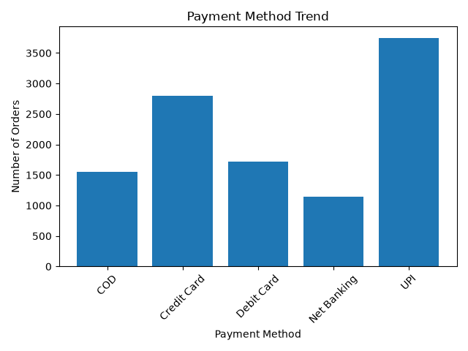
Figure 11: Payment Method Trend
Table 5: Orders by payment method (Figure 9) and revenue (dashboard)
Payment method | Orders (approx.) | Share of orders | Revenue (dashboard, M)
UPI | ≈3,740 | ≈34% | 61.32
Credit Card | ≈2,790 | ≈26% | 45.08
Debit Card | ≈1,720 | ≈16% | 26.96
COD | ≈1,550 | ≈14% | 24.15
Net Banking | ≈1,140 | ≈10% | 18.44

Observation. UPI has the most orders (≈3,740), followed by Credit Card (≈2,790). Debit Card (≈1,720) and Cash on Delivery (≈1,550) are similar, and Net Banking is the least used (≈1,140). The dashboard revenue ranking matches the order ranking exactly.
Interpretation. UPI and credit card together account for about 60% of orders, so customers strongly prefer digital payments. COD remains a meaningful share, at about 14% of orders. Although titled “Trend”, this chart shows totals by method, not change over time.

6.7 Relationships between discount, price, quantity and profit
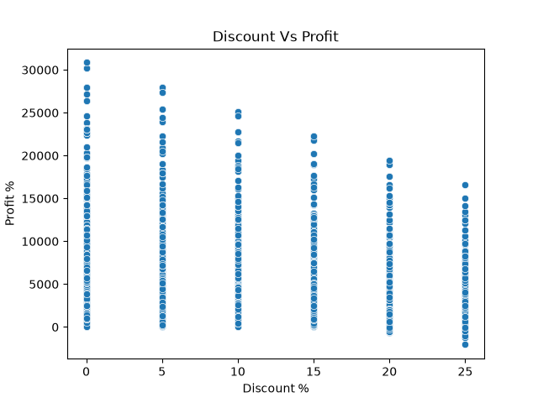
Figure 12: Discount Vs Profit
Observation. Each column of points is one discount level. The highest profit visible at each level falls steadily as the discount rises: about 31K at 0%, 28K at 5%, 25K at 10%, 22K at 15%, 19K at 20% and 16.5K at 25%. Profit values below zero appear only at the 20% level (slightly) and at the 25% level (down to about −2,000). The y-axis is labelled “Profit %” but the values (up to about 31,000) are profit amounts.
Interpretation. Deeper discounts cap the profit a transaction can earn and are the only cases where transactions lose money. This is consistent with the correlation of −0.24 between discount and profit in Figure 12. The chart does not show how many transactions are involved at each level.
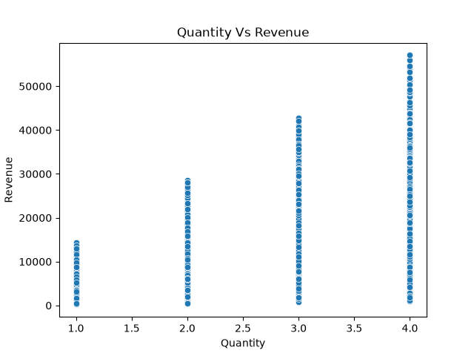
Figure 13: Quantity Vs Revenue
Observation. Quantity takes only the values 1 to 4. The highest revenue at each quantity rises roughly in proportion: about 14K for one item, 28K for two, 43K for three and 57K for four. At every quantity, revenue also includes small values near the bottom of the chart.
Interpretation. Buying more items raises the potential order value, but the spread within each quantity shows that unit price matters as much as quantity. The highest-value orders in the dataset are four-item purchases.
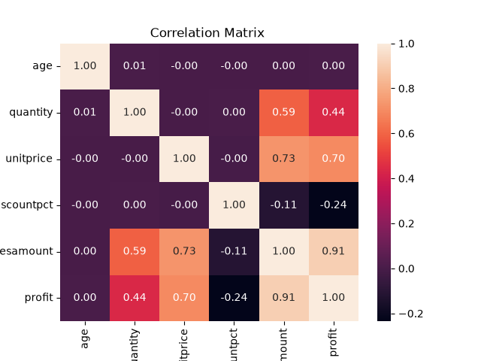
Figure 14: Correlation Matrix
Table 6: Key correlations from Figure 12
Variable pair | Correlation | Strength
salesamount and profit | 0.91 | Very strong positive
unitprice and salesamount | 0.73 | Strong positive
unitprice and profit | 0.70 | Strong positive
quantity and salesamount | 0.59 | Moderate positive
quantity and profit | 0.44 | Moderate positive
discountpct and profit | −0.24 | Weak negative
discountpct and salesamount | −0.11 | Very weak negative
age and every other variable | 0.00 to 0.01 | No relationship

Observation. Sales amount and profit are very strongly related (0.91). Unit price is the strongest driver of both sales (0.73) and profit (0.70), and quantity is a moderate driver (0.59 and 0.44). Discount is weakly negative with profit (−0.24) and very weakly negative with sales (−0.11). Age shows no relationship with anything. Unit price, quantity and discount are unrelated to each other (all about 0.00).
Interpretation. Pricing, not customer age, shapes revenue and profit. Discounts show no sign of increasing the sales amount in this data and are associated with lower profit. Correlation does not prove cause, and it is not shown whether sales amount is measured before or after the discount.

6.8 Returns
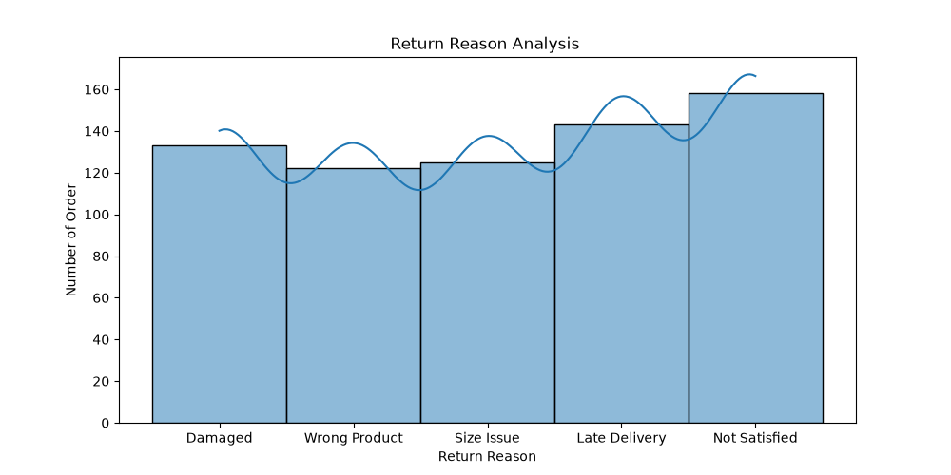
Figure 15: Return Reason Analysis
Table 7: Returned orders by reason (approximate, read from Figure 15)
Return reason | Orders | Share of about 681 returns
Not Satisfied | ≈158 | ≈23%
Late Delivery | ≈143 | ≈21%
Damaged | ≈133 | ≈20%
Size Issue | ≈125 | ≈18%
Wrong Product | ≈122 | ≈18%

Observation. The five reasons are fairly evenly spread, from about 122 to 158 orders each, totalling about 681 returned orders. “Not Satisfied” is the largest reason, followed by “Late Delivery” and “Damaged”.
Interpretation. No single cause dominates, so there is no one quick fix. Late Delivery, Damaged and Wrong Product together make up about 58% of returns (≈398 of ≈681), and these point to fulfilment issues the business can control. “Not Satisfied” is too general to explain on its own. The smoothed curve drawn over the bars has no meaning for categories and should be ignored.

6.9 Hypothesis test: discount versus no discount
The correlation analysis in Section 6.7 suggests that discounts do not raise the sales amount. To test this question formally, the average order value (AOV) of discounted orders was compared with that of orders without a discount, using a Welch two-sample t-test in Python (Jupyter Notebook and Hypothesis_Testing.py).
- Null hypothesis (H0): the mean AOV of discounted and non-discounted orders is the same.
- Alternative hypothesis (H1): the mean AOV differs between the two groups.
- Test and threshold: Welch’s t-test with a significance level of α = 0.05. Welch’s version was chosen because order values are right-skewed (Section 6.1) and the two groups are unlikely to have equal variances.
- Effect size: the difference in mean AOV, reported with a 95% confidence interval.
Table 7A: Welch t-test result, discount versus no discount (AOV)
Measure | Result
Mean AOV, discounted orders | [add]
Mean AOV, non-discounted orders | [add]
Difference in means | [add]
Welch t-statistic | [add]
p-value | [add]
95% confidence interval for the difference | [add]
Decision at α = 0.05 | [add]

Interpretation. [Replace this with your result in one or two sentences, for example whether the p-value is below 0.05 and whether the confidence interval excludes zero.] Statistical significance alone does not justify discounting: any gain in AOV has to be weighed against the lower profit per transaction seen at higher discount levels (Section 6.7). The test compares two groups and does not prove that discounts cause the difference.

7. Dashboard Analysis
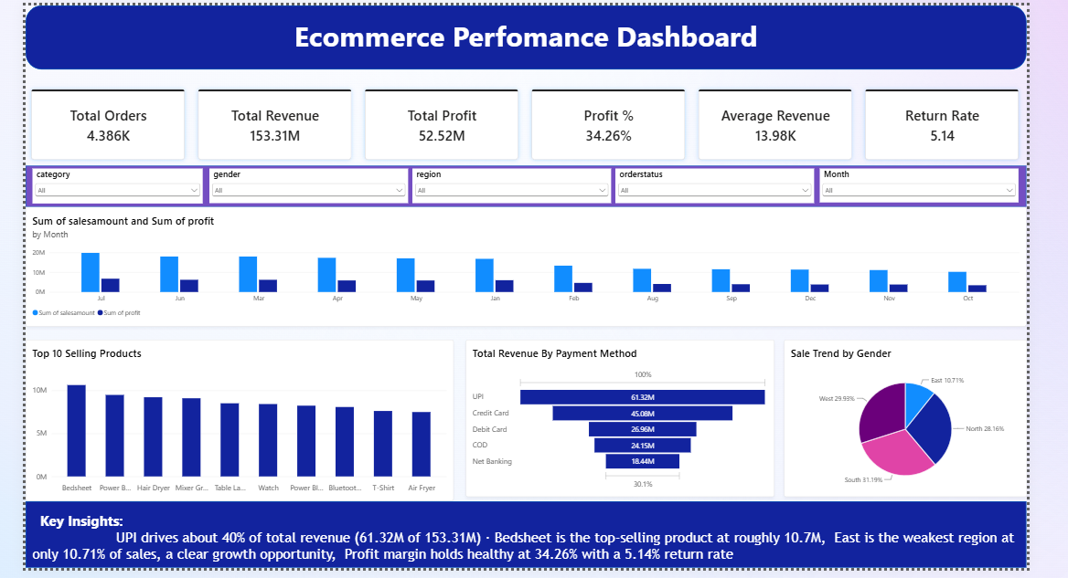
Figure 16: E-Commerce Performance Dashboard

7.1 What the dashboard shows
The dashboard summarises the business on a single page. It has a row of six KPI cards, five filters, a monthly revenue-and-profit chart, a top-10 products chart, a payment method funnel, a pie chart of revenue shares, and a short Key Insights box.

7.2 Main KPIs
Table 8: Dashboard KPI cards
KPI | Value | Comment
Total Orders | 4.386K | Definition not stated; see Section 10
Total Revenue | 153.31M | Matches the sum of monthly revenue in Figure 3
Total Profit | 52.52M | Matches the sum of monthly profit in Figure 4
Profit % | 34.26% | 52.52M ÷ 153.31M
Average Revenue | 13.98K | Average sales amount per transaction
Return Rate | 5.14 | Shown without a unit; presumably a percentage

7.3 Filters and categories
The dashboard can be filtered by category, gender, region, order status and month. This lets users view results for a single category or region without changing the dashboard layout. The values inside the gender and order status filters are not visible in the material.

7.4 Main visuals and relationships
- Revenue and profit by month: July has the highest totals (revenue about 20M) and October the lowest (about 10.5M). Profit follows revenue in every month. Because this chart adds the same calendar month across all years, January to July include three years of data while August to December include only two. Part of the apparent drop after July therefore comes from the data coverage. On average per year (Figure 3), July is about 5.7M, August about 5.3M and October about 4.6M, and February is the lowest at about 3.9M.
- Top 10 selling products: Bedsheet is first at about 10.7M, and the remaining nine products decline gradually to about 7.5M.
- Revenue by payment method: UPI leads with 61.32M, followed by Credit Card (45.08M), Debit Card (26.96M), COD (24.15M) and Net Banking (18.44M). The dashboard states that UPI drives about 40% of total revenue.
- Sale Trend by Gender (pie chart): the chart title says gender, but the slices are labelled by region: South 31.19%, West 29.93%, North 28.16% and East 10.71%. The content is therefore a regional revenue split. No gender analysis can be drawn from it.

7.5 Key insights from the dashboard
- UPI drives about 40% of total revenue (61.32M of 153.31M).
- Bedsheet is the top-selling product at roughly 10.7M.
- East is the weakest region at only 10.71% of sales, a clear growth opportunity.
- The profit margin is healthy at 34.26%, with a 5.14 return rate.

8. Key Findings and Insights
The findings below are the strongest points supported by the charts and dashboard.
- Stable profitability. The overall margin is 34.26%, and the monthly margin stays between about 33% and 35.5%. Profit follows revenue closely (correlation 0.91).
- East is the weakest region. It provides 10.71% of revenue against 28.16% to 31.19% for the other regions, with a similar margin of about 35%.
- Home and Electronics lead. They provide about 27% and 26% of revenue and the highest profits. Books are the smallest category but appear to have the highest margin (about 38%).
- Discounts reduce profit. The correlation with profit is −0.24, the maximum profit per transaction falls at every discount step, and negative profit appears only at 20% and 25% discount.
- Price drives value. Unit price has the strongest link to sales (0.73) and profit (0.70), ahead of quantity (0.59 and 0.44). Age has no link.
- Digital payments dominate. UPI is first by orders (≈3,740) and revenue (61.32M), and UPI plus credit card make up about 60% of orders.
- Revenue is seasonal but not growing steadily. February is the lowest month in all three years (≈4.13M, ≈3.74M, ≈3.79M), July is strong, and monthly revenue stays within about 3.7M to 6.1M.
- Returns are an operational issue. About 58% of returns come from late delivery, damage and wrong products.
- Bedsheet is the top product on both the dashboard and Figure 14, and the top ten products account for roughly half of revenue.

9. Recommendations
Each recommendation below is linked to a finding from the data. The data shows what is happening, but it does not explain why, so some recommendations start with further investigation.
Table 9: Findings and the recommendations based on them
Finding from the data | Recommendation based on that finding
East contributes only 10.71% of revenue, but its margin (≈35%) is similar to other regions. | Investigate the causes of low volume in East (for example reach, delivery coverage and marketing) and run a targeted pilot campaign there. The margin does not need fixing.
Home and Electronics provide about 53% of revenue and the highest profit. | Give these categories priority in stock planning and promotion, and keep best-selling items such as Bedsheet well stocked.
Books have the highest estimated margin (≈38%) but the lowest revenue. Beauty has the lowest margin (≈31%). | Test ways to grow Books sales, and review Beauty pricing and costs. Cost data is not available, so start with a pricing review.
Higher discounts are linked to lower profit (−0.24) and loss-making transactions appear only at 20% and 25%. | Review and limit the use of 20% and 25% discounts, and test whether discounts actually increase orders before extending them.
Unit price is the strongest driver of sales (0.73) and profit (0.70). | Promote higher-priced products and bundles that increase the number of items per order.
UPI and credit card make up about 60% of orders, and UPI leads revenue. | Keep UPI and credit card checkout fast and reliable. Consider payment-method offers, and monitor COD (≈14% of orders).
February is the lowest month in all three years, while July is strong. | Plan campaigns for February and make sure stock and staffing are ready for the June to July peak. Treat the pattern as tentative (three years only).
About 58% of returns are Late Delivery, Damaged or Wrong Product. “Not Satisfied” is the largest single reason. | Improve packaging, order checking and delivery partner performance. Collect more detailed feedback to understand “Not Satisfied” returns.
Revenue shows no steady growth trend (monthly range ≈3.7M to 6.1M). | Set growth targets for volume, since margin is already stable, and track monthly progress on the dashboard.

10. Limitations
The following limitations are visible in the dataset and in the analysis:
- Charts and dashboard as the evidence base. The figures in this report are read from charts and a dashboard rather than queried directly from the database. The exact number of records and variables, the original source of the CSV files and the business name are not stated. Re-running the key figures in SQL would replace the approximate (≈) values with exact ones.
- Approximate values. Values marked with “≈” were read from chart axes and may differ slightly from the true values.
- Short time period. The data covers 31 months. Seasonal patterns rest on only two or three observations of each month, and the last month (July 2026) may not be complete.
- Missing variables. There are no cost, customer ID, repeat-purchase, marketing, delivery time or competitor data, so the reasons behind patterns (for example low East revenue) cannot be established.
- Correlation is not causation. The relationships between discount, price, quantity and profit are associations only.
- Cleaning results are not yet documented. Duplicate and null checks were run in SQL, but the number of issues found and how they were handled are not recorded in this report.
- One formal test only. Only the effect of discounts on average order value was tested formally. The other findings, such as the East region, payment methods and returns, are descriptive.
- Scope. Customer gender is available as a filter, but no gender analysis is shown.

Consistency issues found in the source material
Comparing the charts and the dashboard revealed several differences that cannot be resolved from the material. They should be checked against the raw data before the results are used for decisions.
Table 10: Items that could not be reconciled
Item | Issue
Total Orders (4.386K) | The payment method counts sum to about 10,900 orders, and 153.31M ÷ 13.98K is about 10,970 records. The meaning of Total Orders is not stated. The database has separate orders and orderdetails tables, so Total Orders may count orders while the ≈10,970 figure counts order lines; a row count on each table would confirm this.
Dashboard totals | The payment method values sum to 175.95M, and the monthly bars add up to roughly 176M to 178M. The KPI card, the category and region charts and the monthly line chart (Figure 3) all give about 153M. The dashboard visuals are about 15% higher, possibly because of different order status filtering, but this cannot be confirmed.
UPI share | The dashboard states about 40% (61.32M of 153.31M). Relative to the sum of the payment method values (175.95M), UPI is about 35%, which is close to its share of orders (≈34%).
Top 10 products | Dashboard values (for example Bedsheet at about 10.7M) are higher than Figure 14 (≈9.2M), and the order of Table Lamp, Watch, Air Fryer and T-Shirt differs.
Return Rate (5.14) | No unit or base is shown. About 681 returned orders (Figure 15) cannot be tied to this rate without that information.
Labels and chart types | The pie chart titled “Sale Trend by Gender” shows regions. Figure 10 is labelled “Profit %” but shows profit amounts. Figure 9 is titled “Trend” but shows totals. Figure 15 draws a smoothed curve over categories. Some axis labels are cut off (Figures 5 to 8 and 14).

11. Conclusion
This project examined the performance of an e-commerce business using a PostgreSQL database for storage and cleaning, Python for exploratory charts and a hypothesis test, and an interactive dashboard. The business generated 153.31M in revenue and 52.52M in profit, a margin of 34.26%, and this margin is remarkably stable across months and regions. Profit rises and falls with sales volume, which means that growth in volume is the main route to higher profit.
The analysis found that Home and Electronics are the strongest categories, that UPI is the preferred payment method, and that unit price is the strongest driver of revenue and profit. It also identified three clear areas for improvement: the East region, which contributes only 10.71% of revenue; discounts of 20% and 25%, which are linked to the lowest profits and to the only loss-making transactions; and fulfilment-related returns, which account for about 58% of all returns.
These findings matter because they point to specific, practical actions that are supported by the data. At the same time, several differences between the dashboard and the charts, and the absence of cost, customer and time-detail data, mean that the results should be verified against the raw dataset before they are used for business decisions. Future work could add cost data, customer-level analysis, further hypothesis tests (for example on regional differences and return rates) and a forecasting model for monthly revenue.

12. References
- Dataset: Ecommerce_Analytics database (customers, products, orders, orderdetails and returns tables), loaded into PostgreSQL 18 from CSV files.
- Original source of the CSV files: [add the source, if the course requires it]
- Tools: PostgreSQL 18 and pgAdmin; Python (Jupyter Notebook, VS Code, Hypothesis_Testing.py).
- Project portfolio: muhammadusman2008.lovable.app

